R-L series circuit
A circuit that contains a pure resistance R ohms connected in series with a coil having a pure inductance of L (Henry) is known as RL Series Circuit. When an AC supply voltage V is applied, the current, I flows in the circuit.
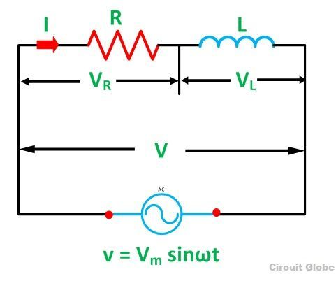
So, I_{R} and I_{L} will be the current flowing in the resistor and inductor respectively, but the amount of current flowing through both the elements will be same as they are connected in series with each other. The circuit diagram of RL Series Circuit is shown below:

Where,
- V_{R} – voltage across the resistor R
- V_{L} – voltage across the inductor L
- V – Total voltage of the circuit

Phasor Diagram of the RL Series Circuit
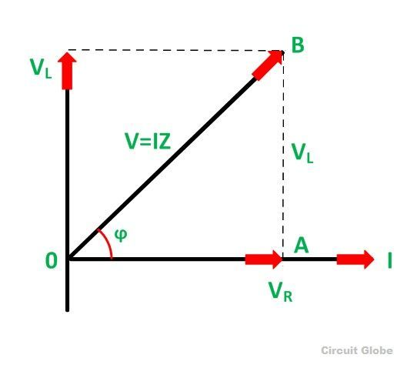
The phasor diagram of the RL Series circuit is shown below:

Steps to draw the Phasor Diagram of RL Series Circuit
The following steps are given below which are followed to draw the phasor diagram step by step:
- Current I is taken as a reference.
- The Voltage drop across the resistance V_{R} = I_{R} is drawn in phase with the current I.
- The voltage drop across the inductive reactance V_{L} =IX_{L} is drawn ahead of the current I. As the current lags voltage by an angle of 90 degrees in the pure Inductive circuit.
- The vector sum of the two voltages drops V_{R} and V_{L} is equal to the applied voltage V.
Now,
In right-angle triangle OAB
V_{R} = I_{R} and V_{L} = IX_{L} where X_{L} = 2πfL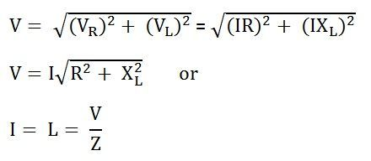
Where,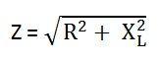
Z is the total opposition offered to the flow of alternating current by an RL Series circuit and is called impedance of the circuit. It is measured in ohms (Ω).

Phase Angle
In RL Series circuit the current lags the voltage by 90 degrees angle known as phase angle. It is given by the equation: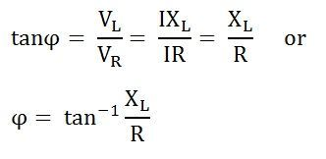

RC Series Circuit
A circuit that contains pure resistance R ohms connected in series with a pure capacitor of capacitance C farads is known as RC Series Circuit. A sinusoidal voltage is applied and current I flows through the resistance (R) and the capacitance (C) of the circuit.
The RC Series circuit is shown in the figure below:
Where,
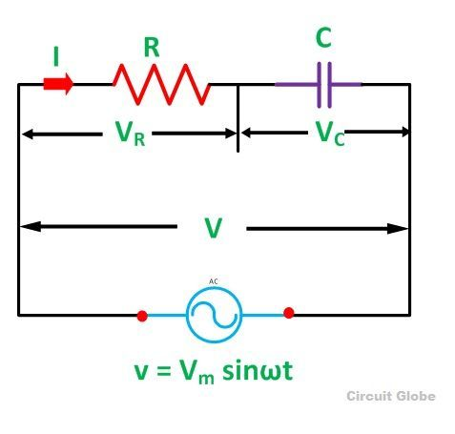

- V_{R} – voltage across the resistance R
- V_{C} – voltage across capacitor C
- V – total voltage across the RC Series circuit

Phasor Diagram of RC Series Circuit
The phasor diagram of the RC series circuit is shown below:

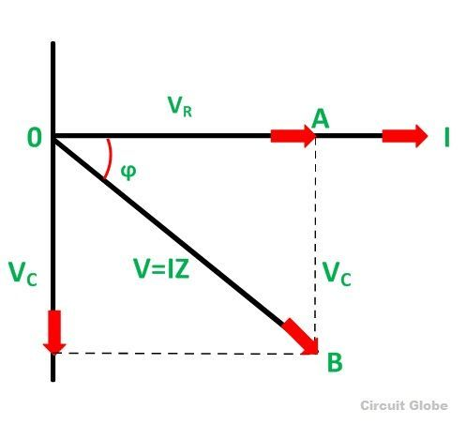

Steps to draw a Phasor Diagram
The following steps are used to draw the phasor diagram of RC Series circuit
- Take the current I (r.m.s value) as a reference vector
- Voltage drop in resistance VR = IR is taken in phase with the current vector
- Voltage drop in capacitive reactance VC = IXC is drawn 90 degrees behind the current vector, as current leads voltage by 90 degrees (in the pure capacitive circuit)
- The vector sum of the two voltage drops is equal to the applied voltage V (r.m.s value).

V_{R} = I_{R} and V_{C} = IX_{C}
Where X_{C} = I/2πfC
In right triangle OAB,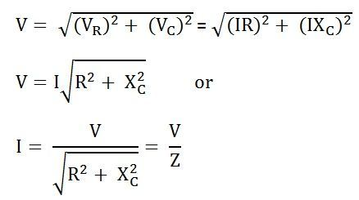
Where,
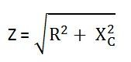
Z is the total opposition offered to the flow of alternating current by an RC series circuit and is called impedance of the circuit. It is measured in ohms (Ω).

Phase angle
From the phasor diagram shown above, it is clear that the current in the circuit leads the applied voltage by an angle ϕ and this angle is called the phase angle.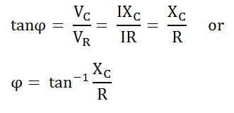

Phasor in ac circuit
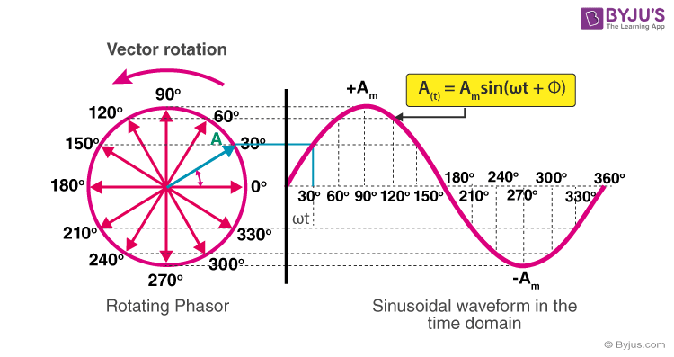

A phasor is a vector that is used to represent a sinusoidal function. It rotates about the origin with an angular speed ω. The vertical component of phasors represents the quantities that are sinusoidally varying for a given equation, such as v and i. Here, the magnitude of the phasors represents the peak value of the voltage and the current. From the figure shown above, we can see the relation between a phasor and the sinusoidal representation of the function with respect to time.

